SOP TITLE: **PROCEDURE FOR CLEANING VALIDATION AND CLEANING VERIFICATION**

1. **Objective:**

The objective of this document is to establish a standard written procedure for cleaning validation in order to verify the effectiveness of the cleaning procedure that the equipment is consistently cleaned of the product chemical and microbial residues to an acceptable level for the prevention of cross contamination.

1. **Scope:**

This Standard Operating Procedure is applicable to all the cleaning acitivites of products and equipment / machines of the PharmEvo.

1. **Reference:**
   1. WHO Guidline TRS 1019-Appendix 3 Cleaning Validation
   2. [EMA] - European Medicines Agency - Guideline on setting health based exposure limits for use in risk identification in the manufacture of different medicinal products in shared facilities CHMP/ CVMP/ SWP/169430/2012
2. **Responsibility:**
   1. Assistant Manager QA is responsible to prepare, revise and provide training of the SOP.
   2. Validation Team is responsible for preparation of Cleaning validation protocol & report and execution of the Cleaning validation as per approved protocol.
   3. Senior Manager Production / Designee will ensure availability of all involved equipment, well kept and clean before performing the sampling of cleaning validation.
   4. Production department will intimate for sampling of Cleaning validation study after proper cleaning of used equipment.
   5. Production department will also ensure that protocols are followed and all relevant SOPs are approved & in place. All concerned personnel have proper training and education required for execution of relevant jobs.
   6. Engineering Department is responsible for the equipment technical documentation, measuring of surface area of equipements & services i.e. Equipment manuals.
   7. Manager Quality Control / Designee is responsible to review validation documents and provide resources required for tests to be performed as a part of the Cleaning Validation. QC is also responsible to perform the Recovery studies.
   8. General Manager PD/Designee is responsibe to develop the cleaning method of newly induct molecule in facility with Risk assessment and also responsible to perform the cleanaiblity studies for hard to clean substance.
   9. Senior Manager QA is responsible to ensure the cleaning validation activites are performed in compliance with the standard requirements.
   10. General Manager Quality Operations is responsible for the overall implementation of the SOP.
   11. Quality Assurance Department is responsible for controlling of this SOP.The author and the reviewer of the SOPs are responsible for ensuring that all the steps and activities in the SOP are accurate, clear and appropriately detailed to the extent that someone with necessary background could accomplish the operation.
3. **Definitions:**
   1. **Changeover Cleaning:** Cleaning performed to remove residual material to meet acaceptance criteria when switching from one substance to another substance.
   2. **Campaign:** Consecutive batches (lots) of an active pharmaceutical ingredient (API), a drug product or an intermediate produced during multipurpose or sinlge purpose (dedicated) equipment, following which the production system is cleaned.
   3. **Marker:** the therapeutic compound identified as the most difficult to clean when a cleaning matrix for multiple products/equipment is used.
   4. **Validation:** Establishing documented evidence that provides a high degree of assurance a specific method , process , or systems will consistently perform as intended.
   5. **Cleaning Verification:** Systematic tests or procedures to demonstrate effectiveness of a cleaning process.
   6. **Cleanibility:** The ability of a cleaning procedure to effectively remove material, cleaning agent residue and microbial contamination.
   7. **Equipment Train:** The sequence of equipment through which a product is produced or processes.
   8. **Investigation:** A systematic and thorough inspection and examination of records, evidence, and other available facts related to an unusual or unexpected occurrence, such as failure of a product to meet specifications, action levels, or other predicted results or the failure of a system to perform as validated.
   9. **Permitted Daily Exposure (PDE) or Acceptable Daily Exposure (ADE):** A substance specific dose that is unlikely to cause an adverse effect if an individual is exposed at or below this dose every day for a lifetime.
   10. **Product Contact Equipment:** Equipment that includes surfaces expected to be contacted by the next process in such a way that the material B could become contaminated by residue left from material A.
   11. **Qualified (when applied to a person):** Person sufficiently trained in procedures and skills with documented evidence of competence to perform assigned tasks.
   12. **Therapeutic Dose:** Acceptable quantity of a drug to be administered; usually expressed as weight (e.g., mg) of activity.
   13. **Validation Master Plan:** A comprehensive, project-oriented action plan that describes the purpose, scope and approach for the validation activities. The plan defines in order of execution the specific tasks, responsibilities, documentation requirements, and programs that are required to achieve validation.
   14. **Validation Protocol:** A written plan of action designed to gather documented evidence that will support or refuse a stated premise or meet an objective, such as validating a process.
   15. **Validation Report:** An approved document that summarizes the results of a validation project, addresses any deviations to the validation plan, specifies limitations or restrictions determined during the validation process, includes recommendations for implementation, and concludes with a statement regarding the validated state.
4. **Materials & Equipment:**

N/A

1. **Precautions:**
   1. Appropriate personal protective equipment (PPEs) will be used by the persons involved in cleaning validation, sampling and testing.
   2. After completion of sampling (Rinse & swab) Validation Team/ Microbiologist will affix the label on sampling container which conatins the following information:
      1. Equipment Name:
      2. Product Name :
      3. Batch No.:
      4. Sampled type:
      5. Sampling Date:
      6. Sampling time:
2. **Procedure :** 
   1. Cleaning program is to be defined in Validation Master Plan. The VMP shall include a list of Products requiring cleaning validation.
   2. Before cleaning validation is initiated, the equipment, areas and utilities involved should be qualified.
   3. Product Development will develop cleaning procedure of new molecules, as per SOP # PDG/2/046, after performing cleanability studies and share change control with validation department alongwith technology transfer having cleanability studies records. Validation department will prepare protocol as per the design method and validate at commercial scale on 03 conecutive runs.
   4. Product Development will develop cleaning procedure of existing / legacy molecules after performing cleanability studies and share change control, if any change required, with validation department with cleanability studies records. Validation department will prepare protocol as per the design method and validate at commercial scale on 03 conecutive runs.
   5. The cleaning procedure should specify the level of cleaning to be undertaken, cleaning intervals and frequency and the methodology to be utilized. The procedures should be well defined to ensure consistency of operation whether they are manual or automated.
   6. The maximum number of consecutive batches in the equipment (dedicated or nondedicated) prior to cleaning should be specified and justified (such maximum number is equivalent to the campaign and needs to be specified).
   7. Cleaning Validation is typically performed concurrently, when validating a new or modified cleaning procedure.
   8. Cleaning procedures in shared facilities should be based on a science and risk-based approach and refer to a toxicological evaluation as appropriate for establishing threshold values for risk identification.
   9. This approach utilizes the setting of health-based exposure limits for the determination of Acceptance daily exposure (ADE) values as a basis for establishing appropriate limits. ADE (Acceptance daily exposure) for all new molecules and for all existing products will be established by an external toxicologist.
   10. The risk assessment strategy should consider as a priority for highly hazardous product categories. The hazardous products are identified using the ADE categorization which utilizes toxicological data based on Acceptance daily exposure (ADE).
   11. The risk assessment will consider the facility and equipment design and product mix and any other relevant point which are as following:
       1. Dedicated versus non-dedicated equipment
       2. The risk of cross-contamination, e.g. between active pharmaceutical ingredients
       3. The complexity of the equipment and its ease of cleaning
       4. Involved product, lot sizes, composition (safety data), toxicity, cleanability and solubility
       5. Cleaning process applied (automatic or manual cleaning)
       6. Equipment trains
       7. Substances incompatible with the cleaning process, e.g. as regards surface characteristics (like chemical compatibility of stainless steel)
       8. Required pre-treatments (e.g. deactivating or solubilising)
       9. Holding times, e.g. time between end of use and start of cleaning.
   12. A cleaning validation prototcol shall be prepared and approved. The protocol shall establish how validation will be conducted and shall include or refer but not limited to the following:
       1. the objective of the activity.
       2. the people responsible for performing and approving the validation study.
       3. the description of the equipment to be used, including a list of the equipment, make, model, serial number or other unique code.
       4. Maximum time interval between use and cleaning or between cleaning and use.
       5. the levels of microorganisms (bioburden)
       6. the cleaning procedures to be validated
       7. Residue materials to be removed
       8. the number of cleaning cycles to be performed consecutively.
       9. the sampling procedures to be used (rinse sampling & swab sampling)
       10. Sampling Locations
       11. the data on recovery studies (efficiency of the recovery of the sampling technique should be established).
       12. Test method used for testing samples
       13. Acceptance criteria
   13. Criteria for Equipment cleaning validation for equipments shall be as follows:
       1. Visibly Clean
       2. Analytical verification of residue removal to pre-determined acceptance criteria
       3. The criteria for calculating the MACO
   14. Cleaning procedures for products and processes that are very similar do not need to be individually validated. A validation study of the “worst case” may be considered acceptable. There should be a justified validation programme for this approach, addressing critical issues relating to the selected product, equipment or process.
   15. Where “bracketing” of products is done, consideration should be given to the type of products and equipment.
   16. Bracketing by product should be done only when the products concerned are similar in nature or property and will be processed using the same equipment. Identical cleaning procedures should then be used for these products.
   17. When a representative product is chosen, this should be the one that is most difficult to clean.
   18. Bracketing by equipment should be done only when it is similar equipment, or the same equipment in different sizes (e.g. 300 L, 500 L and 1000 L tanks). An alternative approach may be used to validate the smallest and the largest sizes separately.
   19. **Selection criteria ranking system for determination of worst case product:**
       1. **Worst Case Rating (WCR)/Risk assessment:**
          1. To execute the WCR, a protocol will be prepared in which the rating system will be identified to document the rating by using following criteria which required for the determination of worst case product in shared facility:
          2. Lowest Acceptable Daily Exposure or Permitted Daily Exposure (ADE / PDE )
          3. Hardest to clean (Cleanability studies)
          4. Solubility in used solvent
       2. **ADE or PDE concept:**

The Acceptable daily exposure or Permitted daily exposure define limits at which a patient may be exposed every day for a lifetime with acceptable risks related to adverse health effects. An example of rating numbers, with explanations, is presented in the table below.

|  |  |
| --- | --- |
| Group | ADE/PDE |
| 1 | >500 µg |
| 2 | 100-500 µg |
| 3 | 10-99 µg |
| 4 | 1-9 µg |
| 5 | <1 µg |

The above ADE/PDE values will be provided by service provider Toxicologist.

If two different molecules possess the same PDE values, additional variables such as solubility should be considered for the worst case, otherwise, the least PDE value will remain the worst case.

* + 1. **Hardest to Clean out - Experience from Production:**

Cleanability studies at development stage will identify hard-to-clean substances and rated according to the following three categories:

* + - 1. Easy = 01
      2. Medium = 02
      3. Difficult = 03
    1. **Solubility**

A solubility-rating will be carried out based on the solubilities of the substances in the solvents used for cleaning. Solubility rating numbers with explanations are as following:

|  |  |  |
| --- | --- | --- |
| Group | Included descriptive terms | Approximate quantities of solvent by volume for 1 part of solute by weight |
| 1 | Very soluble  Freely solube | Less than 1 part from 1 to 10 parts |
| 2 | Soluble  Sparingly soluble | From 10 to 30 parts from 30 to 100 parts |
| 3 | Slightly soluble Practically insoluble Insoluble | From 100 to 1000 parts from 1000 to 10000 parts more than 10000 parts - |

* 1. For multi-Product contact equipment,the product sampling locations during change over cleaning validation shall include most difficult to clean equipment locations.This may require dismantling of equipment after cleaning to sample the most difficult to clean locations (e.g. Dead legs & tank bottom valves).
  2. Cleaning Validation failures shall be investigated and where the failure has potential to impact on commercial product , a deviation shall be raised by concerned department.
  3. If the root cause of the failure does not indicate an issue with the cleaning process (e.g. it is associated with the mechanical failure or operator error in following the instructions) then the failed validation run may be replaced by another one to complete the original validation sequence.
  4. If the root cause of the failure is related to the cleaning process , then corrective actions shall be addressed prior to cleaning validation.
  5. Reference of the failing run and associated investigations shall be made in the cleaning validation report, including the decision of how to processed with the validation sequence following such a failure.
  6. If the new product is determine the most difficult to clean compound, then the existing procedures or new procedures shall be validated with at least three consecutive successful execution of the cleaning procedure on the new product.
  7. Maximum allowable time intervals between use and cleaning must be demonstrate in at least one cycle of an equipment use and cleaning by execution of the cleaning procedure.
  8. Test methods used for cleaning validation shall be validated.The analytical methods used shall have sufficient sensitivity to detect the established accaeptable level of residues.
  9. After validation is complete , periodic monitoring of cleaning shall be performed at a defined frequency based on a documented and approved risk assessment of the probability of contamination.
  10. The validated status should be confirmed by periodic reviews which including the following elements & periodic reviews will include a conclusion on the overall outcome.

* + 1. Monitoring results
    2. Change controls
    3. Deviations
    4. Investigation results.
  1. All equipment, after cleaning validation campaign must be re-Cleaned, to remove chemical traces of swabbing for residual API from product contact surfaces, prior to use by Production Department.
  2. Cleaning Validation is not necessarily required for non-critical cleaning such as that which take place between batches of the same product (or different lots of the same intermediate in a bulk process), or of floors, walls, the outside of vessels.
  3. Personnel or operators who perform cleaning routinely should be trained and effectively supervised.
  4. Dedicated equipment should be used for products that are difficult to clean, equipment that is difficult to clean, or products with a high safety risk where it is not possible to achieve the required cleaning acceptance limits using a validated cleaning procedure.
  5. The period and conditions for storage of unclean equipment before cleaning, and the time between cleaning and equipment reuse, should form part of the validation of cleaning procedures.
  6. The relevant cleaning records (signed by the operator, checked by production and reviewed by quality assurance) and source data (original results) should be kept. The results of the cleaning validation should be presented in cleaning validation reports stating the outcome and conclusion.
  7. Validation runs shall be executed using one or more of the following:
     1. Cleaning validation executions performed at the end of a regularly scheduled campaign
     2. Cleaning conducted within a campaign
  8. For drug Product ,excluding dietary supplements ,health based exposure limits shall be used to determine the risks associated with the manufacturing of differnet drug products within a shared facility.
  9. **Calculating the Equipment Surface Areas:**
     1. For all new equipment / machine the surface area that is in contact with the product will be obtained from the OEM by making part of the URS.
     2. For all legacy equipments surface area will be calculated by Engineering Department and verified by Validation Department. To make more stringent MACO value, 10% surface area will be added in final surface area calculation.
     3. All existing equipment train surface area in contact with the product shall be calculated in order to evaluate the sampling results, where applicable.
     4. For a complex piece of equipment, the surface shapes should be simplified with approximate measurements, using worst case approaches, see demographic picture at 8.38.6 below.
     5. The measurements and calculations should be recorded and filed with the project documentation or in a separate technical report which is cross referenced to the project documentation.
     6. Demographic pictorial guide for calculation surface area:

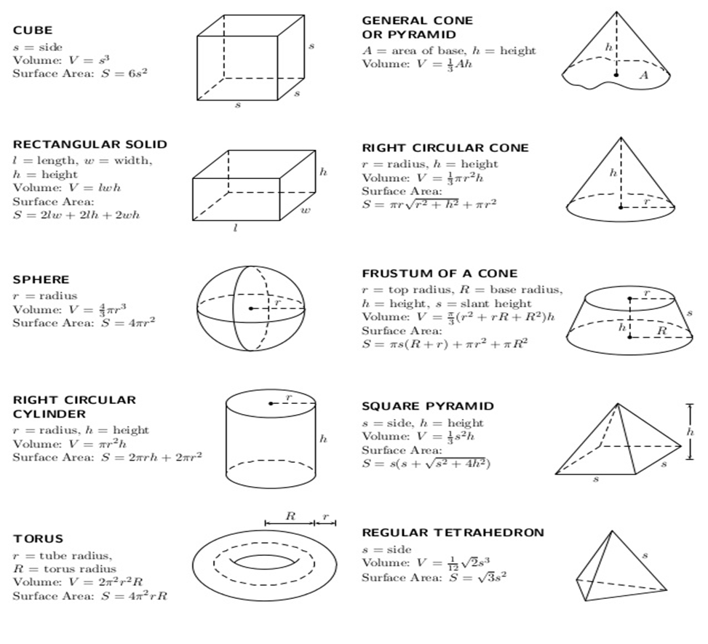

* 1. **Sampling:**
     1. Two methods of sampling are considered to be acceptable. These are direct surface sampling and rinse samples.
     2. **Direct Surface Sampling “Swab Method”:** This method is designed for sampling of hard to clean area i.e. surface of Equipment Machine area etc. Swab of hard to clean areas shall be taken by dragging it on the surface of the equipment horizontally and vertically. Press down the swab handle firmly to ensure proper surface contact.

Swab Samples will be taken and covered 10cm x 10cm for QC testing & 5cm x 5cm area for Microbial testing each point location by applying a total of 35 strokes in right to left and top to bottom & vice versa directions of Equipment or machine parts which have direct contact with product. Swab will be taken in right to left and top to bottom & vice versa directions, as shown below:

Use one swab for each surface sample. Swab is also collected as per above mentioned direction to evaluate chemical and microbiological contamination. For microbiological sampling sterile swabs are required.

* + 1. **Rinse Samples (indirect method):** The residue amount in equipment after cleaning can also be determined by taking rinse samples. Sampling method (Rinsate or swabbing recovery) studies shall be conducted.

Rinsate or swabbing method recovery studies with recoveries of 50% or greater are considered acceptable. When recovery values are less than 70% , the recovery value shall be used as a correction factor in the calculations of results or limits.

When recovery values are between 70 % & 100 %, the recovery values may be used as a correction factor in the calculations of results or limtis , but it is not required. For recoveries greater than 100 % no recovery values shall be used as a correction factor.

* 1. Any modification to the manufacturing process should be managed under change control, assessing the impacts on the related cleaning procedures. Modifications may include for example:
     1. Manufacture of a new product
     2. Changes to the equipment to be cleaned or the cleaning agents used
     3. Modifications to cleaning procedures or establishing new cleaning procedures
  2. **Continued cleaning process verification :**

In this stage it should be demonstrated that the cleaning process remains in control throughout the product lifecycle. The following should be considered in this stage:

* + 1. **Cleaning Verification:**
       1. Cleaning verification prove the effectiveness of a single cleaning event by applying pre-defined methodology. When analytical methods are not fully developed at this stage, alternative procedures such as TOC analysis can be applied.
       2. After sucessful completion of three runs of cleaning validation, cleaning verification of one run of particular worst case will be performed yearly and will become the part of Validation master plan.
       3. Cleaning verification will be be used at predefined frequencies to support the periodical cleaning validation assessment, in particular for manual cleaning procedures.
       4. For cleaning verification, methods and criteria should be in approved state.
    2. **Post Validation Monitoring:** 
       1. After cleaning validation, the analytical verification may be omitted or replaced by simpler analytical methods (e.g. conductivity; pH; etc.) that have proven to be suitable for the intended use. However, visual inspection should be maintained in the dried equipment and no visible residues should be observed. The confirmation of the validation status should be performed periodically according to the periodicity defined in the validation report.
    3. **Change Control:** 
       1. Any change to the cleaning procedure, analytical methods, manufacturing process, equipment, etc. during the execution of the cleaning validation protocol or after the validation is concluded should be handling through the change control procedure in place in the organization. The impact on the cleaning validation process should be evaluated.
    4. **Validation Report** should include:
       1. A precise description of the validated cleaning process, or a reference to the respective plan or protocol.
       2. A description of the operations performed and a statement on whether the validation plan or protocol criteria have been met. In cases where deviations have occurred, an investigation has to be conducted to assess its impact on the cleaning validation success.
       3. A re-statement of the acceptance criteria, and whether they were met or not
       4. The results of the visual inspections and samples
       5. The analysis of the results in relation to the acceptance criteria. Non-compliant results should be investigated and assessed
       6. A conclusion that precisely defines the validated parameters or ranges and states the compliance or non-compliance of the results
       7. Any changes to the protocol that occurred during the cleaning validation (e.g. new version of the protocol and justification)

1. **Training:**

Training will be imparted to the concerned personnel prior to implementation and will be documented in QAG/5/142.

1. **Attachment:**

N/A

1. **Distribution List:**
2. **SOP Revision History:**